Strayer University

**APPLICATION ARCHITECHURE**

Week 1

**Project Plan Inception**

for the

Course of

Systems Analysis and Development

05/29/17

By

Kennedy Kabaso.

Professor: BARRETT, CHRISTOPHER.

**Project Plan Inception**

**Section 1: Project Introduction**

1.Write a two to four (2-4) page project introduction that includes the following:

a.Background information of the company.

b.The type of business in which the company is involved.

c.A description of the information systems that the company should have to support the business. The description should include the following:

i.databases

ii.systems analysis

iii.security

iv.networking

v.computer infrastructure

vi.human computer interaction

vii.Web design

d.The use of at least two (2) quality resources in this assignment. **Note:** Wikipedia and similar Websites do not qualify as quality resources.

Your assignment must follow these formatting requirements:

* This course requires use of [Strayer Writing Standards (SWS)](https://blackboard.strayer.edu/bbcswebdav/institution/STANDARDIZED/StrayerWritingStandards/Strayer_Writing_Standards.pdf). The format is different than other Strayer University courses. Please take a moment to review the SWS documentation for details.
* Include a cover page containing the title of the assignment, the student’s name, the professor’s name, the course title, and the date. The cover page and the reference page are not included in the required assignment page length.

**Section 2: Gantt Chart / Project Plan**

Use Microsoft Project or an open source alternative, such as Open Project, to:

2.Create a Gantt chart or project plan (summary and detailed) template. The Gantt chart or project plan should:

a.Record all tasks, subtasks, resources, and time related to the project.

b.Outline the planning, analysis, design, and implementation phases.

c.Develop in accordance with the systems development life cycle (SDLC).

The specific course learning outcomes associated with this assignment are:

* Describe the various integrative functions and processes within the information systems area, including databases, systems analysis, security, networking, computer infrastructure, human computer interaction, and Web design.
* Demonstrate the ability to evaluate organizational issues with integrative technological solutions.
* Use technology and information resources to research issues in information technology.
* Write clearly and concisely about strategic issues and practices in the information technology domain using proper writing mechanics and technical style conventions.

In this assignment, am going to talk about the architecture which is going to used, the technology which is needed to carry out this, then show the whole process in form of a flow chart and finally, discuss some ethical issues associated with a payroll program for a large organization with offices spread across the United States.

**Type of Architecture for New Payroll Application.**

As this project is about the application architecture with offices which are spread around the country, so it needs a type of network such as a Wide Area Network (WAN). In addition, it needed a type of an architecture which is secure and update regularly. Therefore, I would go for the Client/Server architecture which is the best choice for the new payroll system. Before I go any further, I would like to define this term, Client/server architecture to make it easy to understand. According to an article and I quote “Client/server architecture is a computing model in which the server hosts, delivers and manages most of the resources and services to be consumed by the client.” It is going to be centralized at the headquarter of the company where an Information Technology department is going to be much secured. All other small branches of the company will be connected to access the payroll and the database to this place. The software which is going to be used for payroll is Employee Payroll Management (EPM) with the Microsoft SQL Server which is a database server for Microsoft. The application is going to be install in the client’s workstation where they can be used at the same time all over the country. Moreover, it is efficiency, faster at getting results and easier to use with little training.

**Type of Technology for the Architecture**

What am going to do about this is setup a server which is the main piece in this project. It will have the database for the whole of the company employees who are all over the country. It is going to be secured with an updated security software.  And it is going to be easy to manage all the files, backup them, and the recovery is going to be easy as well. An ongoing change in the world of software, it will be easy to upgrade to a new one. Moreover, it is going to be managed by a Database administrator whose duties are install, configure, design database, migrate, performance monitoring, secure, troubleshoot, backup, recover data and lastly, making sure it is running smoothly. For this to be secured and work perfectly, an Intranet will be the best network connection. Therefore, I will setup the Intranet on a Wide Area Network (WAN) where client computers which are workstations, where the user interfaces with the server can login and get access to the payroll. Moreover, these client’s computers can access the resources from the server of the company.

To carry out this application Architecture, you need an operating system of window server 2008 or new version, Server Software Versions SES 11.2, multi-core server class processor, 4 GB of RAM or more, and 2 TB of hard drive which is on the server’s side. The client on the other hand needs just things such as window 7 or newer version, 2GHz processor or faster, 2 GB RAM Hard Disk 1 GB free hard drive, Display Super VGA 1024 x 768 and other staffs including the above-mentioned ones. Then connect all those client computers which are all over the country to a Domain. If anyone on any geographical area of the country want to connect to this centralized region, must be part of the domain. This given only access to the employee who are in the system. Once they have log in, they can check everything from the leaves in a year once they have been at the company for one year and knows how many weeks they would take their Pay time off (PTO). This depend on company policy which is usually two weeks in most companies in the United States of America. Moreover, employees can clock in and out of work at the end of their shift and get the pay stubs which can be printed if needed.

The administrator on the other hand can get the salary, Attendance and the employee ‘s report which can be printed or view if needed.

To simplified this process, I have shown everything in form of a flow chart below.

**The flow chart for the application architecture.**

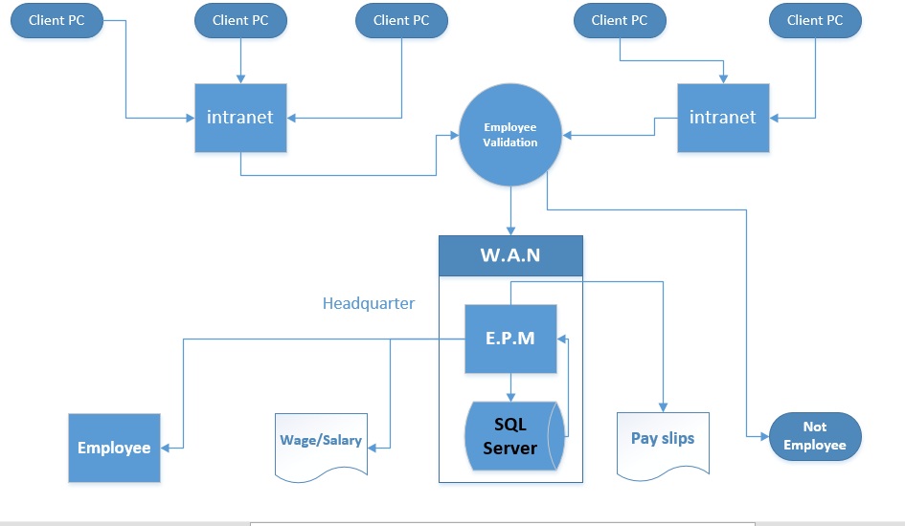

**Ethical Issues on the Architecture.**

There are a lot of ethical issues which can happened with building an architecture of the payroll system which need to be taken into consideration.

Hacking is one of the main issue in payroll system. There are a lot of hackers whose job is to get sensitive information and use it wrongly. There has been an increase in hacking all over the world which required every big company to take it serious. There are some hackers who can easy get to the payroll system of different companies with weak security and get money using another channel. Apart from hacking, there are some mistakes which can happen in the payroll process which usually result in lawsuits. Therefore, most companies employed the best candidate to do the job perfectly to avoid those issues. In addition, they ensured employee are paid on time and according to federal regulation.

**Bibliography.**

<https://docs.oracle.com/cd/E11882_01/owb.112/e17130/overview.htm#WBINS01000>.

<https://docs.oracle.com/cd/E11882_01/owb.112/e17130/overview.htm#WBINS01000>

<http://support.sas.com/resources/papers/proceedings17/SAS0436-2017.pdf>

<http://www.functionx.com/networking/Lesson06.htm>